Islamic Banking and the Development of the Muslim Economy: An Analysis of Its Role and Prospects

Imelda Indrawati Basri
Edumedia Solution Indonesia
Imeldameida57@gmail.com

ARTICLE INFO |  | ABSTRACT (10pt)
Article history  Received : 5 April 2025  Revised : 12 May 2025  Accepted : 30 Juny 2025 |  | Islamic banking plays a crucial role in supporting microeconomic growth in Indonesia, particularly in expanding access to finance based on Sharia principles. This study aims to examine the development of Islamic banking in Indonesia and its contribution to strengthening the micro, small, and medium enterprise (MSME) sector. The method used is a qualitative literature study, which draws on various scientific literature, official documents, and secondary data. The results show that Islamic banking in Indonesia has experienced significant growth since the establishment of Bank Muamalat Indonesia in 1992, followed by the emergence of various Islamic financial institutions, including BPRS (Small and Medium Enterprises) and Baitul Mal wat Tamwil (BMT). The merger of three state-owned Islamic banks into Bank Syariah Indonesia (BSI) in 2021 strengthened the competitiveness of the national Islamic banking industry, particularly in supporting MSME financing amidst the challenges of the Covid-19 pandemic. This study confirms that strengthening Islamic banking is a key element in building economic independence for the people and equitable distribution of social welfare.
Keywords
Islamic Banking, MSMEs, Microeconomics, Islamic Bank Merger, Financial Inclusion

Introduction
A bank is an institution that carries out three main functions: 1. accepting deposits, 2. lending money, and 3. providing money transfer services. In the history of Islamic economics, financing through Sharia-compliant contracts has been part of Muslim practice since the time of the Prophet Muhammad. Practices such as taking deposits, lending money for consumption and trade, and transferring money were commonplace during the Prophet's time. The main functions of banking in the modern era are accepting deposits, transferring money, and carrying out transactions. The ulama signed a joint agreement spearheaded by the Indonesian Ulema Council (MUI):
1. Established a non-Indonesian bank on 18-20 August 1990 in the Bogor area.
2. The results of the seminar were outlined in the Fourth National Resolution of the MUI which was held in Jakarta on 22-25 August 1990.
Based on the terms of reference of the National Resolution of the fourth session of the Assembly Indonesian Ulama. Group activities have been well established. created to create a non-Indonesian bank . Based on the recommendations of the Indonesian Ulema Council (MUI) Seminar, regarding Banking Interests after the Fourth National Debate at the Indonesian Ulema Council and the issuance of Law Number 7: concerning the Principles of Banking in 1992, replacing Law. - Banking Basic Law No. 1 of 1967, which contains the provisions of Article. 1 No. 12, in particular, to allow for banking activities on a profit-sharing basis.
PT. Bank Muamalat Indonesia marks the historical rise of banking development in Indonesia in its journey. Economic activities that lead to the prosperity of the entire community. Sharia banking in the implementation of operations, banks only have commercial purposes, not prioritizing material profit, to achieve happiness in the future. Therefore, in carrying out its banking operations, Sharia banks do not only rely on general provisions existing in banking, but also the provisions of Sharia Banks must comply with Sharia principles and contracts, as applicable from the beginning until its operation .
Microeconomics is the study of economics that analyzes conditions and examines the processes of economic activity (Nur Jamal Shaid, 2022). Microeconomics is a spatial activity, a branch of economics that studies the behavior of individuals, both consumers and industrial companies, and how to determine market prices and the quantity of resources, goods, and services sold in the market (Hidayati, 2023). Based on the description above, we aim to study the history of the development of Islamic banking in Indonesia in the modern era to gain a detailed understanding of the history of Islamic banking in Indonesia in the modern era.

Literature Review
Islamic banking plays a crucial role in supporting financial inclusion and empowering the micro, small, and medium enterprise (MSME) sector in Indonesia. As public awareness of Sharia-based finance increases, Islamic financial institutions are expected to reach segments of society that have not yet accessed formal banking services. Fathihani et al. (2025) in a systematic literature review stated that Islamic banking in Indonesia has a significant influence on increasing financial inclusion, although it still faces challenges in terms of infrastructure, financial literacy, and competition with conventional banks. In the context of MSME financing, Rahmanisa et al. (2024) found that third-party funds (TPF), return on assets (ROA), and the financing-to-deposit ratio (FDR) significantly influence the level of financing provided to MSMEs by Islamic banks. These findings demonstrate a direct link between the internal financial performance of Islamic banks and the effectiveness of productive financing distribution.
Furthermore, the form of working capital financing offered by Islamic banks also has a direct impact on MSME development. Johari et al. (2024) in their study using the Vector Error Correction Model (VECM) in the Special Region of Yogyakarta concluded that Sharia-based working capital financing had a positive impact on increasing the number of business units in the long term. However, in the short term, a negative impact was found on turnover and employment, indicating that such financing requires appropriate adaptation and mentoring to maximize its benefits. Furthermore, the qardh hasan instrument is also an important alternative in microfinance because it is non-commercial and encourages a spirit of economic solidarity. Azizah et al. (2024) emphasized that qardh hasan provides interest-free facilities to micro-entrepreneurs, but its implementation faces technological and managerial efficiency challenges in the digital 5.0 era.
Furthermore, innovation in Sharia financial products is a crucial strategy in driving the growth of MSMEs. Subkhan et al. (2023) demonstrated that waqf-based microfinance institutions, such as Bank Wakaf Mikro KHAS Kempek, successfully disbursed low-margin, collateral-free financing to small businesses while simultaneously promoting community-based empowerment. Similarly, Utomo and Ismal (2024) highlighted the potential of the Cash Waqf Linked Deposit (CWLD) instrument in strengthening Islamic banks' capital and expanding their social reach, particularly in inclusive and sustainable microfinance. Social capital is also a crucial factor in the success of Islamic microfinance institutions. Subchi et al. (2024) emphasized that religious networks, cultural values, and social closeness are the social capital that supports Baitul Mal wat Tamwil (BMT) in reaching communities underserved by conventional banks, while simultaneously strengthening customer trust and loyalty.
Based on recent literature, it can be concluded that Islamic banking is not only an alternative to the conventional financial system but also a strategic force in microeconomic development in Indonesia. Through Sharia-based financing instruments, strengthening social capital, and innovative financial products such as cash waqf and qardh hasan, Islamic banking has proven capable of reaching and empowering MSMEs in a sustainable manner. This role becomes increasingly crucial amid the need for a just, inclusive, and resilient economic system post-pandemic.

Research Method
This study is based on a literature review, meaning the authors analyzed articles relevant to the chosen topic. This study analyzed three public databases, Google Scholar and Science Direct, including the keywords "The role of Islamic banks, microeconomic growth in Indonesia." The literature research steps refer to Romadhon, B., & Susantri (2021).

Figure 1. Schematic data analysis

Results and Discussion
History of the Development of Islamic Banking in Indonesia
In Indonesia, the regulations regarding Islamic banking are stipulated in Law No. 21 of 2008 concerning Islamic banking. The law states that Islamic banks aim to increase the distribution of wealth in society. (Hidayat and Surahman, 2017) . Based on Al Butary, B., Soemitra, A., & Amelia (2022). Islamic banks are banks that operate based on Islamic principles and in accordance with the types of establishment of Islamic general banks, Islamic business units, and Islamic general financial banks (BPRS). The first conventional bank operating in Venice was named Banco della pizza di Rialto since 1587 and is considered the beginning of the development of modern banking with the main instrument being interest rates (investments). These banks have advanced by being brought by banks to several countries, one of which is Indonesia. In the era of Indonesian independence, banking has become more advanced, starting from state-owned and private banks.
According to (Iska, 2012), Bank Muamalat Indonesia was the first Islamic bank to emerge before Law No. 7 was issued by the government. Bank Muamalat was followed by the Sharia Rural Credit Bank (BPRS). ((OJK), b/d) . Since its inception on May 1, 1992, BMI has officially operated with initial capital of Rp. 106,126,382,000.
All these banks have failed to reach the Muslim community at the lowest level, thus the establishment of Islamic financial institutions, for example, Islamic microfinance institutions commonly known as Baitul Mal Watanwil (BMT), which specialize in providing financing to micro, small, and medium enterprises (MSMEs), such as channeling capital for their businesses. In 1998, the government and the House of Representatives (DPR) made improvements to the Digital Technology Law. July 1992 became the law of numbers. October 1998 clearly explained that there are 2 (two) domestic banking systems (dual banking system): the system existing in conventional banking and the system existing in Islamic banking. This opportunity was warmly welcomed by the banking community. This was marked by the emergence of other sharia banks, namely Bank IFI, Bank Syariah Mandiri, Bank Niaga, Bank BTN Syariah, Bank Mega Syariah, Bank BRI Syariah, Bank Bukopin Syariah, BPD Jabar Syariah and BPD Aceh Syariah.
By 1999, Bank Muamalat had 45 branches throughout Indonesia, including in Jakarta, Bandung, Semarang, Balikpapan, Surabaya, and Makassar . After 2000, the development of Islamic banking continued to accelerate. In.. ((OJK), b/d) As of June 2015, Islamic banking financial companies consisted of 12 Islamic commercial banks, 22 Islamic business units (branches) owned by conventional banks, 162 BPRS with total assets of Rp. 273.494 trillion.
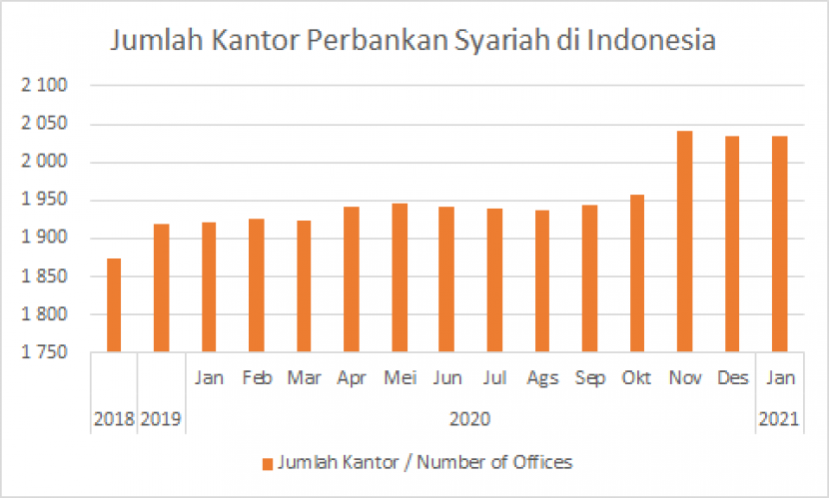
Figure 2. Graph Number of Banking Offices Sharia
((OJK), 2021)
The rise of Islamic banking in the modern era
It is proposed to merge 3 (three) Islamic banks owned by Muslims Himbara, a subsidiary of a state-owned company, namely PT Bank Rakyat Indonesia Syariah Tbk (BRIS), PT Bank Syariah Mandiri (BSM) and PT Bank Negara Indonesia Syariah (BNIS), into one with a new name, logo and identity, namely PT. Bank Syariah Indonesia Tbk (BSI) which has been approved by the Financial Services Authority (OJK). Supervisory Board Number OJK / KDK .03 / 2021 concerning Merger Licensing, and to change the name using the Business License of the Three Islamic Banks to the Business License of PT. Bank Syariah Indonesia Tbk (BSI). Consolidated Bank. The letter was issued on January 27, 2021.
After obtaining OJK approval, the consolidation process of the 3 (three) Islamic banks continued with an application for approval of changes to the rules submitted to the Ministry of Law and Human Rights (KHHAM) and an application for additional listing of Indonesian shares. Exchange. If all processes go according to plan, the Himbara Muslim Bank merger will be effective on Monday, February 1, 2021, with a new name, logo, and identity, namely PT Bank Syariah Indonesia Tbk (BSI) which is more comprehensive, with wider reach and better use. capital. and broad access (BSI, bd).
The initial establishment of Bank Syariah Indonesia (BSI) was part of the government's efforts and commitment to advancing the sharia economy as a driving force in the national economy. (Romadon and Susantri, 2021) He also received support from BSI Chief Executive Heri Gurardi. Hyeri is optimistic that BSI can become one of the world's top five capitalists within the next three years.
In fact, the merger was carried out to survive the COVID-19 pandemic crisis and increase the penetration of Islamic property, as Islamic assets are very different from conventional assets. Following the merger, Bank Syariah Indonesia (BSI) stated that the Islamic banking sector continued to grow strongly even amid the pandemic. The recorded growth even surpassed that of the conventional banking sector. BSI President and CEO Heri Gunardi stated that the Islamic banking sector in Indonesia recorded a 13.9% increase in assets to IDR 69 trillion in 2021. Meanwhile, funding also reached IDR 22 trillion, a 6.9% increase from the previous year.
The Covid-19 pandemic has impacted all industries. At the global economic level, the impact of the COVID-19 pandemic on the national economies of countries and the existence of small and medium enterprises (Muttaqin et al., 2020) Despite the current situation during the Covid-19 pandemic, PT Syariah Indonesia (BSI) Bank has achieved savings growth of 11.57% compared to the same period last year. Thus, in 2021, total savings reached 91.3 trillion rupiah. This achievement places BSI among the top five national banking companies in terms of savings. In the decision-making process of Islamic banks through mergers, mergers are usually carried out to increase market share, reduce operational costs, expand into new regions, combine similar products, increase sales, and increase profits. All of these provisions are aimed at increasing shareholder income. The disadvantage of mergers is that it is difficult to easily separate duties and responsibilities. Not to mention the management of investors and shareholders on both sides. This is especially true if one company is in an unhealthy financial condition.

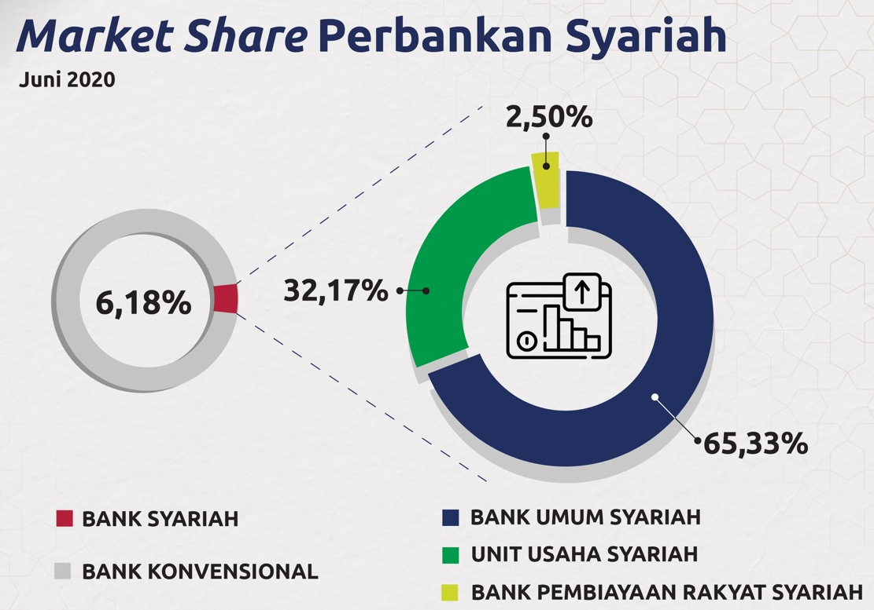
Figure 3. Share market (Bareksa, nd)
The market share of Islamic banking also increased to 6.18%, with the share of Islamic commercial banks at 65.33%, Islamic business units (branches) at 32.17%, and Islamic commercial banks at 2.5%.

Table 1. New composition resulting from the merger
Bank name | Share before the merger | Assets
BRIS | 17.4% | Rp. 49.6 trillion
BSM | 51.2% | Rp. 114.4 trillion
BNIS | 25% | Rp. 50.8 trillion
Source: Indonesia, 2021

This data makes Islamic banks stronger in facing market competition and the current crisis caused by changes in the COVID-19 pandemic . Furthermore , the combined banks will focus on financing MSMEs, retail, corporate businesses, and even large-scale infrastructure projects .
The reasons behind the bank merger (Merger) are to: survive the Covid-19 pandemic crisis, increase the penetration of sharia assets, integrate the Indonesian sharia financial industry, increase global competitiveness.
Economic Development Micro
The industry most impacted by the Covid-19 pandemic is micro, small, and medium enterprises (MSMEs), which contribute to the stagnation of the national economy. According to the Ministry of Cooperatives, Small, and Medium Enterprises, in 2018, the number of MSMEs was 6.2 million, or 99.99% of the total number of corporate entities in Indonesia. While the contribution of small, medium, and micro enterprises to national economic development was 61.1%, the remaining 38.9% were large businesses, which only contributed 5,550 or 0.01% of the total number of businesses. Micro businesses dominate among MSMEs with 98.68%, while the share of the workforce is 89%. At the same time, the contribution of micro businesses to national GDP is around 37.8%.

Conclusion
Banks that carry out operational activities based on Sharia principles and are Sharia Commercial Banks, each Sharia Business Unit (branch), and Sharia People's Financial Bank (BPRS) as an institution. The banking sector still does not have access to the Muslim community at the grassroots level, so the creation of Sharia financial institutions such as Sharia Microfinance or better known as Baitul mal watanwil (BMT), which specializes in providing financing to micro, small, and medium enterprises (MSMEs) and business capital. To maintain market stability and competition, Sharia banks and state-owned enterprises are consolidating. This merger will bring together the interests of the three Sharia banks to obtain a more complete picture. As a result of the above, future researchers are expected to increase the number of reference articles and journals so that they can compare the results of research on one object with another. To continuously improve the quality and resources, in this case, journal journalists are expected to be better in the future than they are now.

References
Al Butary, B., Soemitra, A., & Amelia, A. (2022, December). Analysis of the Presence of the First Islamic Financial Institution and the Contribution of Muslim Scholars in Indonesia. In Proceeding of International Conference on Science and Technology (Vol. 1, No. 1, pp. 99-111).
Azizah, D. S., Pratama, A. G., Madina, D. S., Yolanda, A. J., & Anggraini, S. N. (2024). Konsep Perbankan Syariah Dalam Pembiayaan Usaha Mikro, Kecil, dan Menengah Melalui Data Qardh Hasan di Era 5.0. Journal of Economics and Business, 2(2). https://doi.org/10.61994/econis.v2i2.494
Fathihani, Wafi, I. N., & Rosdiana, R. (2025). The Impact Of Islamic Banking On Financial Inclusion In Developing Countries: A Systematic Literature Review. AL‑ARBAH: Journal of Islamic Finance and Banking, 7(1). https://doi.org/10.21580/al-arbah.2025.7.1.25711
Hidayat, YR, & Surahman, M. (2017). Analysis of the Achievement of Sharia Banking Goals Based on Law No. 21 of 2008 Amwaluna : Journal of Sharia Economics and Finance, 1(1), 34–50.
Hidayati, S. (2023). The Development Of Microeconomic Theory Learning Modules. Peka, 11(1), 23-31.
Johari, S. M., Larasati, D., & Hariyadi, E. (2024). Kontribusi Pembiayaan Modal Kerja Perbankan Syariah Terhadap Perkembangan UMKM di DIY. EKOMA : Jurnal Ekonomi, Manajemen, Akuntansi, 3(4), 1580–1592. https://doi.org/10.56799/ekoma.v3i4.3650
Rahmanisa Aulia Safitri, Mukhtar, S., & Zahra, S. F. (2024). MSME Financing in Indonesia Islamic Banks: Impact of Third‑Party Funds, ROA, and FDR. JEKSYAH: Islamic Economics Journal, 4(01), 39–49. https://doi.org/10.54045/jeksyah.v4i01.1507
Romadon, B., and Susantry. (2021). The relationship between the merger of three Islamic banks and public awareness of Islamic banking products . Al-Tamwil: Islamic Economic Studies, 3(1), 86–98.
Subchi, I., Jahar, A. S., & Prasetyowati, R. A. (2024). Is Social Capital Determinant in Developing Islamic Microfinance Institutions? Etikonomi, 23(1), 233–248. https://doi.org/10.15408/etk.v23i1.31769
Subkhan, M., Hardiyanto, F., Widya, W., & Maghfiroh, D. (2023). Sharia Financial And Banking Product Innovation In SMEs Development. International Journal of Social Research, 1(1). https://doi.org/10.59888/insight.v1i1 Agustus.3
Utomo, G. S., & Ismal, R. (2024). Cash Waqf Linked Deposit Potential for Revitalizing Islamic Banking in Indonesia. Share: Jurnal Ekonomi Dan Keuangan Islam, 13(1), 71–91. https://doi.org/10.22373/share.v13i1.22087

